Patrolling Emission in the United States

Andrew Goetz - ENGR-1110-005 (Carbon Cops)

Our team plans on creating two executable programs in Python which will display air pollution in China in different manners. The first program we’ve designed is an interactive program which, upon running, prompts the user with two drop-down boxes to select an air pollutant (SO2, NO2, CO, O3) and a city in China.

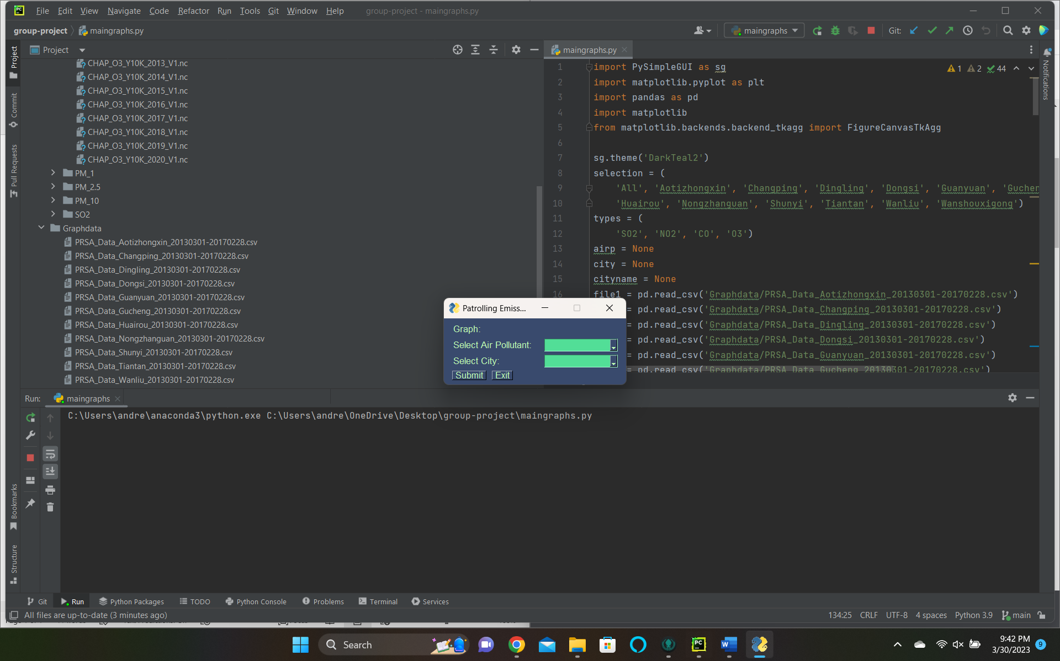

Once the user selects a pollutant and a city, the program will successfully output a stem plot of the city’s selected pollutant emissions over a four year span, highlighting large spikes in pollution measured hourly over a four year span. This program can be run at the maingraphs.py file of group-project.

Our second program, which is still in progress, is an interactive map of pollution across China over a specific time period. A piece we’d like to include is a sliding bar to change the year for which data is displayed on air pollution. We’re still working on this portion, but our end goal is to create a map similar to this one from Sonsuz Design.

**Resources:**

Trello: <https://trello.com/b/yUj3e1jq/engr-1110-group-005>

Shapefiles for interactive map: <https://github.com/dongli/china-shapefiles>

Dataset for air pollution graphs: <https://www.kaggle.com/datasets/sid321axn/beijing-multisite-airquality-data-set>

Interactive map source: <https://sonsuzdesign.blog/2020/08/01/the-beginners-guide-building-interactive-maps-in-python/>